IT Workshop

Task-1: To define computer, describes the characteristics and block diagram of a computer, generations of computer, types of computer and Identify the peripherals of a computer, components in a CPU and its functions.

A computer is an electronic device which accepts information and processes the information according to the program and produces the output. Computer programs may be written in High level languages like Pascal, Fortran, Cobol and so on. Some programmer also writes assembly language to carry out the desired task.

- Characteristics of Computer

1. High Memory
2. Fast
3. Accurate
5. Reliability
6. Networking Capacity
7. Versatility -> computers can be used in many areas like business, schools, home, making movies etc.

- History

- First mechanical computer developed by Blaise Pascal in 1640.

- First computing instrument ABACUS was developed in 400 B.C. Gradually Napier’s bones (1600), Pascal’s first computer (1642), Leibnitz’s mechanical calculator (1771), Babbage’s difference engine (1822) were developed.

- First computer MARK-1 started the modern computer technology and generation of computers.

- In software, British mathematician Augusta Ada Byron was the first programmer to program Babbage’s Analytical Engine (1836).

- BASIC was introduced by John Kemeny and Thomas Kurtz at Dartmouth College in 1965.

- IBM PC was introduced in 1981.

- First Macintosh computer, the “MAC” with graphic interface, developed in 1984.

- Windows 1.01 from Macintosh was introduced in 1985.

- Windows 3.1, very popular was introduced in 1992.

- Classification of Computer Systems

Classification of Computers is based on following 4 criteria:

1. According to Purpose
2. According to Technology Used
3. According to Size and Storage Capacity
4. According to Historical Advancement

- According to Purpose

It is divided into 2 types:
1. General Purpose Computers
2. Special Purpose Computers

- According to Technology Used

It is divided into 3 types:
1. Analog Computers
2. Digital Computers
3. Hybrid Computers

- According to Size and Storage Capacity

It is divided into 4 types:
1. Supercomputer
2. Mainframe Computer
3. Minicomputer
4. Microcomputer

- According to Historical Advancement

It is divided into 6 Generation types:

1. Zeroth Generation Computers (1642 – 1946)
2. First Generation Computers (1946 – 1954)
3. Second Generation Computers (1954 – 1964)
4. Third Generation Computers (1964 – 1980)
5. Fourth Generation Computers (1980 – till date)
6. Fifth Generation Computers (Tomorrow’s Computers)

The Zeroth Generation Computers was marked by the invention of mechanical computers.

The First Generation Computers was marked by the use of vacuum tubes or valves.

The Second Generation Computers was marked by the use of transistors.

The Third Generation Computers was marked by the use of Integrated Circuits (ICs).

The Fourth Generation Computers was marked by the use of Large Scale Integrated (LSI)

Circuits. Very Large Scale Integration (VLSI) is the latest technology of computers.

The Fifth Generation Computers are still under R & D stage. These would have Artificial
Intelligence. They will use Ultra Large Scale Integration (ULSI) chips in place of VLSI.

- BASIC FUNCTIONAL UNITS OF A DIGITAL COMPUTER

A computer system has five basic functional units which are listed below

- Input Unit
- Output Unit
- Control Unit
- Memory Unit central processing unit
- Arithmetic Logic Unit

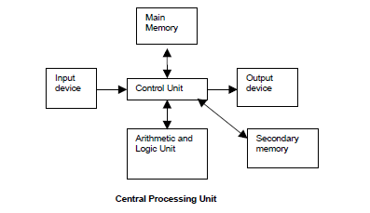
The figure shows the computer organization depicting the basic units of a computer.

- Input unit:
The input device is used to enter data and information into a computer. The devices like keyboard, mouse and scanner are commonly used as input devices. A keyboard is used to enter alphanumeric characters and symbols. The mouse is used to pick or select a command from the monitor screen. A scanner is used to scan an image or read a barcode and so on.

- Central Processing Unit:
The processing unit comprises a processor which interprets the program instructions in memory, controls the flow of data and performs arithmetic and logical operations. The program instructions are processed one at a time along with the necessary data. The results are sent to memory and the next instruction is processed. This method is repeated until the program is executed.
- Arithmetic and Logic unit:
The arithmetic-logic unit (ALU) is the unit of the computer that performs arithmetic and logical operations on the data. This section of the machine can be relatively small consisting of circuits and registers which perform arithmetic (+, -, *, /) and logic (>,<,<=,>=,etc) operations. Arithmetic-logic units which can add and subtract and perform logical operations form the backbone for the arithmetic and control operations in computers. To perform scientific calculations the floating-point number system is used.

- Control unit:
The control unit controls the overall activities of the components of the computer. It is mainly used to coordinate the activities among other units. It will send commands signals and controls the sequence of instructions to be executed. The control unit may be defined as “the parts that effect the retrieval of instructions in proper sequence and application of the proper signals to the arithmetic unit and the other parts”.
The function of the control circuitry in a general purpose computer is to interpret the instruction words and then sequence the necessary signals to those sections of the computer that will cause it to perform the instructions.

- Memory Unit:

It is used to store the data, instructions and information before, during and after the processing by ALU. It is also known as Main/Primary/Internal Memory.

It is divided into 3 types:

- 1. Read Only Memory (ROM)/Non-Volatile Memory
- 2. Random Access Memory (RAM)/ Volatile Memory
- 3. Complementary Metal Oxide Semiconductor Memory (CMOS)

- Read Only Memory (ROM)/Non-Volatile Memory

- ROM is permanent and is not erased when system is switched off.

- ROM is also called Nonvolatile Memory. Memory capacity varies from 64 KB to 256 KB (1 KB = 1024 bytes).

- Types of ROM

- 1. Mask ROM
- 2. PROM (Programmable Read Only Memory)
- 3. EPROM (Erasable Programmable Read Only Memory)
- 4. EEPROM (Electrically Erasable Programmable Read Only Memory)
- 5. EAPROM (Electrically Alterable Programmable Read Only Memory)

The most important ROM chip(s) we should know about is the Basic Input/output system or BIOS. The BIOS is a collection of small computer programs built into a ROM chip.

- Random Access Memory (RAM)/ Volatile Memory

RAM is temporary and is erased when the computer is switched off. RAM is also called volatile Memory. Memory capacity varies from 640 KB to several megabytes (1 Megabyte = 1024 KB).

Types of RAM

1. Dynamic RAM (DRAM)
2. Static RAM (SRAM)
Differences between Dynamic RAM & Static RAM

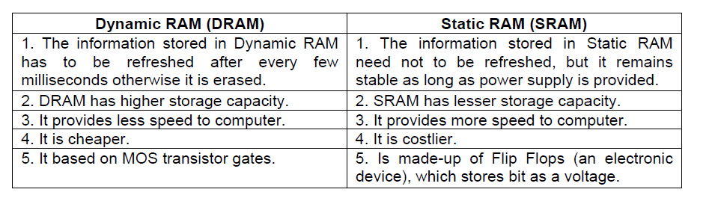

- Output Unit:
The output device is used to display or print result from a computer. Monitor, printer and plotter are commonly used output devices. A monitor is used to display the result in the form of text and graphics. The printer is used to print the result. A plotter is used to plot or print graphical result from a computer. Note that a result displayed in a monitor is temporary and it disappears when the next result is displayed, whereas the output printed using a printer or a plotter is permanent and these printouts can be used for any business correspondence or documentation. Normally soft copy is referred to information that is stored on the storage device. A hard copy refers to a print out showing the information.

Parts of a Computer

To learn more about the components of a computer, let us examine the various parts that are visible from outside. Basically, a computer consists of a CPU, a monitor, a mouse and a keyboard. Some Computers may also contain additional accessories like speakers, a microphone, a headphone etc. The additional accessories simply facilitate us to use the computer fro doing something extra. A discussion on the essential and optional components of the computer will be taken up later on in this chapter. For the moment, let us discuss the components of a simple computer.
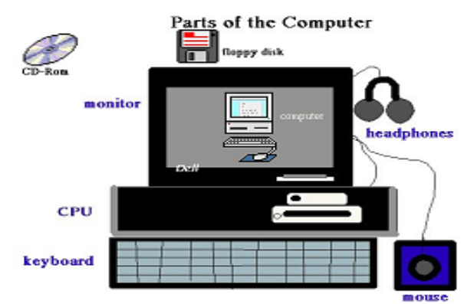

Central Processing Unit: The Central Processing Unit (CPU) of computer is usually located in a tower-shaped cabinet. The CPU consists of different smaller components like the motherboard, hard disk, RAM, floppy disk drive, sound card etc. These components are discussed in the next section.

Monitor: Monitor is a television-like equipment which displays the output of a computer. Monitors can be monochrome (black and white), LCD (liquid crystal display), VGA or SVGA. Further, monitors can be analogue or digital.

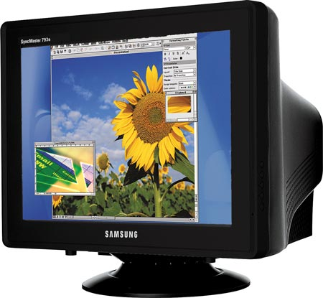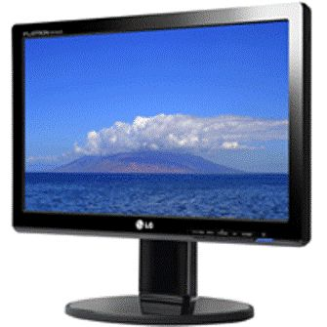

Mouse: Mouse is a small component that fits inside out palm. It contains buttons (two or three) which help us work on a computer conveniently.

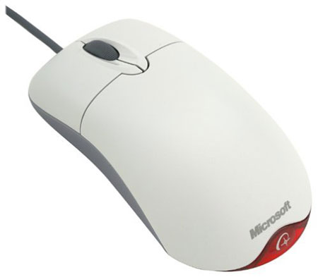

Keyboard: Keyboard is a typewriter like device which contains key to feed information into the computer.
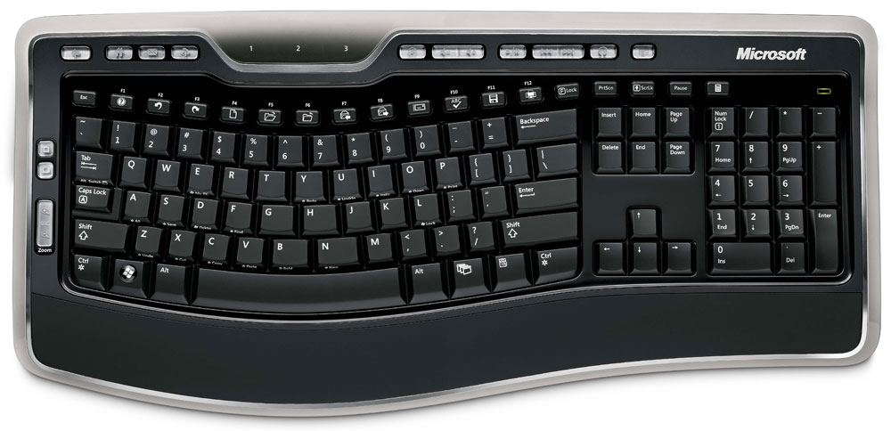

Components of a PC
Basic Components | Optional
- Processor  - Hard disk  - RAM  - Display / Video card  - Keyboard  - Drives : Hard Disk, Floppy Disk and CD-ROM  - Mouse  - Monitor | - Printer  - Scanner  - Modem  - DVD drive  - Speakers  - Zip Drive

The System Unit
The Keyboard, monitor, mouse, printer, etc. are all linked to the System Unit through cables which are plugged into the back of the System Unit. The hard disk, the floppy disk drive and the CD-ROM drive are placed inside this unit.

Vital components of the System Unit.

- Hard Disk: The hard disk is a device which stores all programs and data in the computer. The capacity of the hard disk is measured in Giga Bytes (GB). Larger the hard disk capacity, more the amount of software programs and information that can be stored in it.
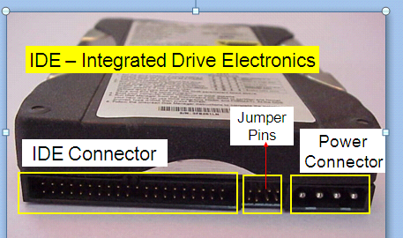

- Motherboard: The motherboard is a flat platform of fibre glass on which the electronic components in a PC are mounted. The motherboard is also called a Printed Circuit Board (PCB)
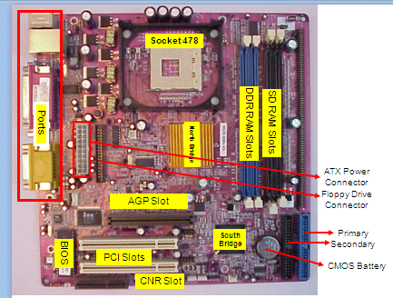
- Central Processing Unit (CPU): The Central Processing Unit (CPU) contains the microprocessor chip which undertakes all the thinking for the PC and runs the programs according to the user’s commands and requests.
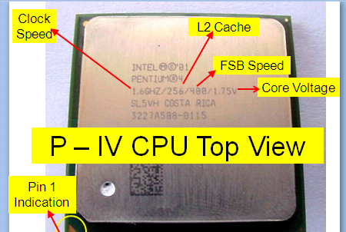

Following are the various types of CPU chips:
  - Pentium
  - Pentium Pro
  - Pentium III
  - Pentium IV
  - AMD Athlon
  - Intel Celeron
  - AMD Duron
  - Cyrix

- CD-ROM Drive: CD-ROM drive is a device that reads the information stored on CD-ROM disks, CD-ROM is an abbreviated term for ‘Computer Disk – Read Only Memory’. The Speed of a CD-ROM drive is indicated by a number followed by the alphabet ‘X’. The 56X CD-ROM is currently the most popular drive specification. The CD-ROM disk is flat and circular in shape and can store a lot more information as compared to a floppy disk.

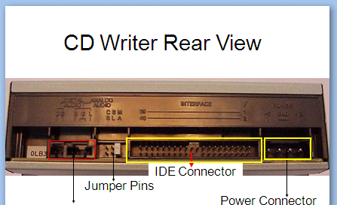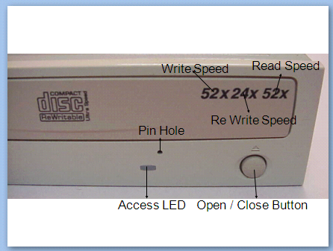

- Floppy Disk Drive: Floppy disk drive is a component that enables us to read/store information on floppy disks. The floppy disk drive consists of a slot to accept a floppy disk, a motor to spin the disk, and a recording/reading device that moves across the disk to read or write data. A floppy disk (also called diskette) is used to store information just as hard disk. It is a removable device, its capacity is (1.44 MB). A PC has 3½ “ floppy disk drive.
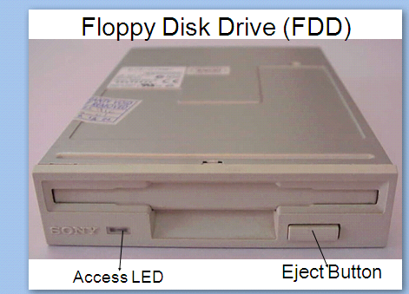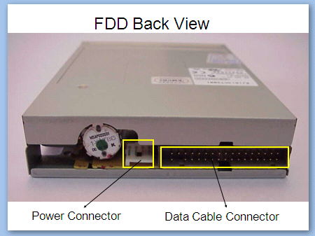

- Math Co-processor Slot: Some PCs contain a slot where a Math Co-processor can be inserted. This processor assists the CPU in performing its mathematical operations. Computers above the 486 grade, Math Co-processor is already in-built in the CPU chip.

- RAM Chips: RAM stands for Random Access memory, RAM chips are components that help the computer to hold the program and it data temporarily while the computer is working. RAM chips come in memory sizes of 16 MB, 32 MB, 64 MB, 128 MB and so on.

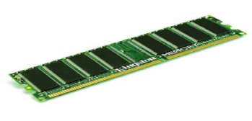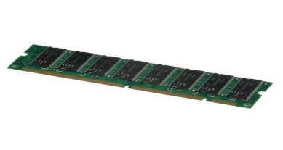

- RAM Chip Slots: These slots are meant to expand the computer’s random access memory by incorporating additional RAM chips.

- Over-Drive Chip: The Over-Drive chip increases the processing speed so that the performance of the computer is improved.

- SCSI: SCSI stands for ‘Small Computer System Interface’ (pronounced skuzzy). An SCSI provides an internal connector which in turn allows to connect the computer to an external storage dev ice.

- Power Supply Unit: The components in a PC can work only when they get electric supply. Most components require a 5 Volt supply while the floppy and the hard disk require about 12 Volts. The power supply unit safeguards the PC components by converting high-voltage current to low voltage.

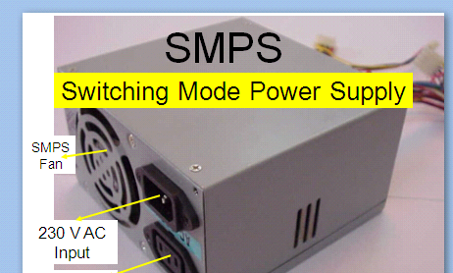

- Disk Drive Control Card: This stand controls the disk drive motors of the PC and transfers data to the control circuitry and directs the read/write heads to access data on the disk. It is permanently inserted in the motherboard.

- Display/Video/Graphic Card: Display card is used to display the data to the user. It is indirectly linked with the computer memory. Nowadays, it is inbuilt in the motherboard. Two types of display cards are available. PCI graphics card and the AGP card.

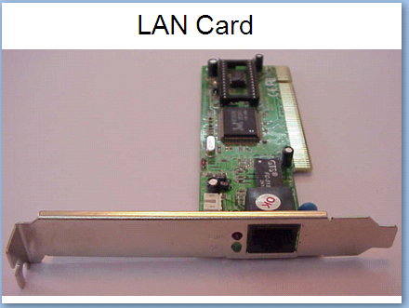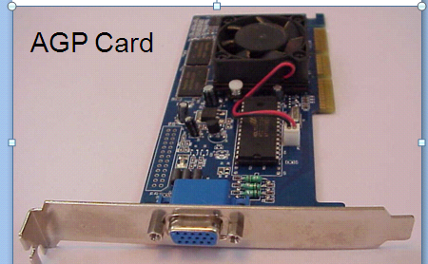

- Printer Adaptor Card: The display / printer adaptor card is the link between the PC’s memory, the monitor and the printer. It displays the information on the monitor as well as allows it to be printed.

- Expansion Slots: Expansion slots are long and narrow connectors which allow to plug in expansion cards (also called adaptor cards), like the sound card, network card etc.

- ROM Chips: Read Only Memory (ROM) chips have data written on them during manufacturing, that tells the CPU the tasks that it needs to carry out when the CP switched on.

- Sound Card: This card allows you to play sound and music. The sound card converts the digital information into electrical signals that speakers use. When the speaker is connected to the sound card, the sound can be heard on the speaker.

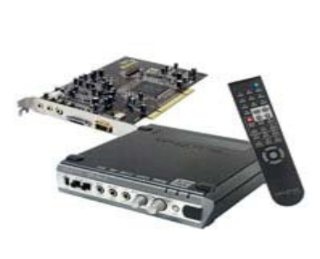

The Front Part of a System Unit
The various components seen in the front part of a System Unit and their functions:
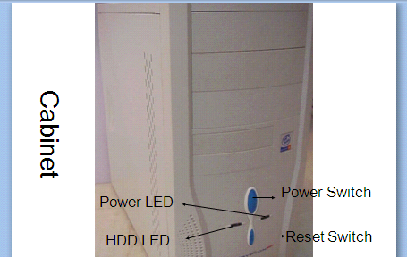

a) Power switch: The power on/off switch is used to turn on or off the power to the PC.

b) Reset button: This button helps to restart the computer without disconnecting the power supply.

c) Lights: The front panel of the system unit may display a variety of cloloured indicator lights including power and turbo signals. These lights are used to indicate whether the hard disk, the floppy disk or the CD-ROM is being read or written.

d) Floppy Disk Drive: The System Unit contains a slit in which the floppy disk can be inserted.

e) CD-ROM Drive: CD-ROM drive is used for reading the information stored on CD-ROM disks.

f) Removable Storage Drives: Removable storage drive is an external device that can be connected to the computer are CD writers and rewriters.

The Backside of a System Unit
The back of the System Unit contains ports of various types. These are the Parallel Port, the Serial Port and the Universal Serial Bus (USB).
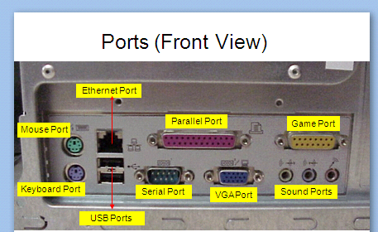

Power IN and OUT Sockets: The sockets have cables plugged into them, which carry the power from the electrical outlet to the System Unit, and from the System Unit to the monitor.

Serial Ports: Serial ports connect the PC to a mouse or a modem. Most PCs are fitted with two serial ports.

Video/Monitor Port: A cable from the monitor plugs into the video/monitor port and carries the information to be displayed on the monitor.

Parallel port: The parallel port is usually used for connecting the computer to a printer. Very often, it is referred to as the printer port. Its data transfer speed is about eight times faster than the serial port.

Keyboard Port: The cable from the keyboard plugs into the keyboard port.

USB Port: A USB port is used for connecting any device with a USB connection.

Fan Housing: During operation, the electronic, components in a PC generate a lot of heat, which is liable to overheat the system. To remove excess heart from the system, fan is placed at the back of the unit.

Audio jack: An audio jack is used for connecting devices such as speakers headphones or microphones.

Modem jack: This jack is mainly used in case of internal modems.

SCSI port: The Small Computer System Interface (SCSI) port is used to connect the external hard drive, the DVD drive or the scanner.

Network port: The network port allows you to connect a computer to other computers in a netwo

Task-2: To explain the process of assembling and disassembling the CPU.

- Setting up a System

Setting up a system i.e. connecting the monitor, System Unit, keyboard, the mouse and the UPS

- The keyboard has a plug which is round in shape and has 5 small pins. Connect this plug to the tower (A).
- The plug of the mouse goes to the tower or the system unit at the back (B).
- The monitor has two plug cables. One of these cables connects to the tower (C).
- The printer plug is connected to the tower (D).
- The speakers are connected to the tower (E).

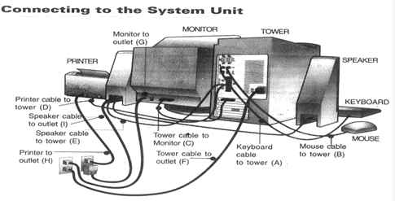

- The keyboard has a plug which is round in shape and has 5 small pins. Connect this plug to the tower (A).
- The plug of the mouse goes to the tower or the system unit at the back (B).
- The monitor has two plug cables. One of these cables connects to the tower ( C ).
- The printer plug is connected to the tower (D).
- The speakers are connected to the tower (E).

- Connecting the Electrical Wires

- The system unit or the tower to the outlet (F).
- The monitor has two cables and one of them carries the electrical supply. Connect the monitor to the outlet (G).
- The printer plug should be connected to the electrical supply (H).
- The plug carrying the electrical current to the speaker should be connected to the outlet (I).

- Turning on the System

- Switch on the outlet button from where the computer is getting the power.
- Push on the POWER button located on the front of the tower or the system unit. a light will glow indicating that the system is switched on. You may also hear whirring noises. This means that your system is booting up.
- Switch on the button on the monitor. This will start the monitor and will be indicated by a light.
- Wait for the computer to complete the booting process and display the next item i.e. the box that enables you to log on to Windows by providing a password.

- Logging on

After turning on a system, you will want to establish ownership. This is called logging on. If your computer connected to a network, a box will popup and ask you to type in your user name and password. Usually, the user name is your last name, but it can be anything.

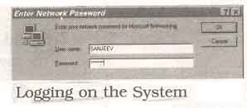

- Disassembling a PC

- Requirements for Disassembling:

- P.C Which is assembled
- Screw driver
- Cutting player
- Tester

- Procedure:

- Step1: Shut down the PC if it is running
- Step2: Switch of power supply and remove power cables from the power supply switch.
- Step3:Remove all the cables connected to CPU i.e.,.
- Power plugs which are connected to CPU and Monitor
- . Remove all the cables from Input/ output panel ports.
- Display cable
- Keyboard
- Mouse
- Printer and LAN
iii. Input/ output Ports available are:

- Display port
- Ps/2 Port
- USB Port [ universal serial bus]
- LAN and Printer Port
- Audio ports
- Serial Port
Step4: Remove the screws of the slides from the cabinet and then remove the slides from the Cabinet

tep5:Remove the power cables and data cables which are connected to mother board and hard disk, CD-Drive , Floppy Drive.

Step6: Remove the front panel cables from the motherboard which are power –led , key switch, hard disk ,drive led, Reset switch led, turbo switch led.

Step7: Remove the cable of Mother Board speakers.

Step8: Remove the screws of SMPS and Remove SMPS from the Cabinet.

Step9: Remove all expansion cables from motherboard which are LAN, MODEM, Display…

Step10: Remove the screws of Hard Disk , CD-Drive and Floppy drive and then remove Hard Disk, CD-Drive , Floppy drive from the Cabinet.

Step11: Remove the Screws of Mother Board and then remove motherboard from the cabinet.

Step12: Remove the Locks of RAM and then remove the RAM from motherboard

Step13:Remove the Power cable of processor Fan.

Step14: Remove the Locks of Processor fan and the Remove Fan from the Processor.

Step15: Remove the heat sinker from Processor.

Step16: Open interlocks of processor and then remove the processor from processor slots/slogs.

Step17: Remove the CMOS Battery (Locks) from the Motherboard

- ASSEMBLING

- REQUIREMENTS FOR ASSEMNLING THE P.C TOOLS:-

- Screw Driver
- Cutting Player
- Tester

- COMPONENTS FOR P.C:

- Case
- Mother Board (ATX & NLX)
- Connectors
- Power supply
- Front Panel (power switch led)
- Back I/O panel (serial, parallel , USB Ports)
- Expansion Slots
- Memory module
- CPU
- Fans and Filters.

- Steps Required for P.C ASSEMBLING:

- Step1: Installation of CPU(Follow motherboard Manual)Install Heat sinker Fan, do CPU arrangements , CPU sockets and Slots.

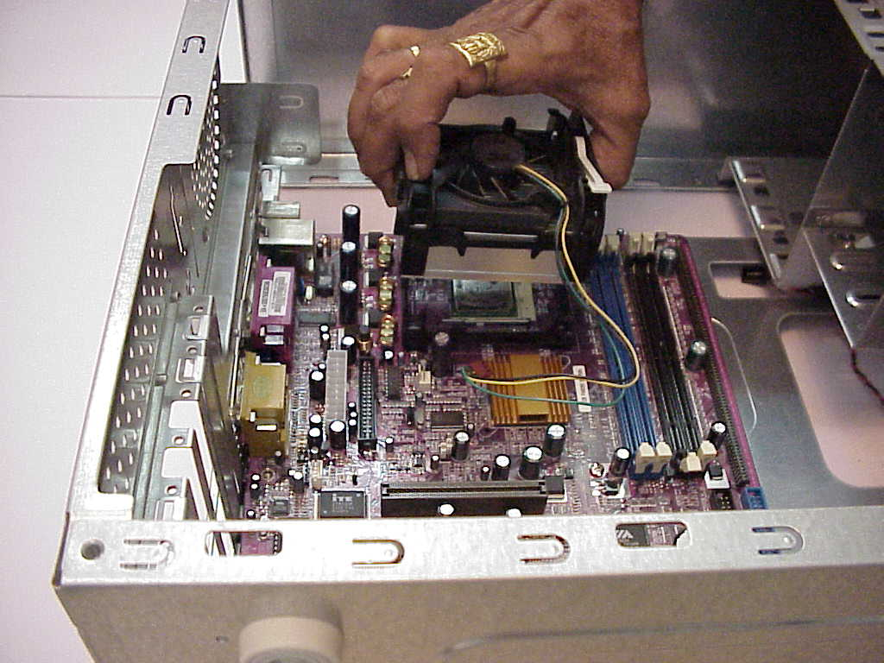
- Step2: Installation of Memory , SDR and DDR Memory.

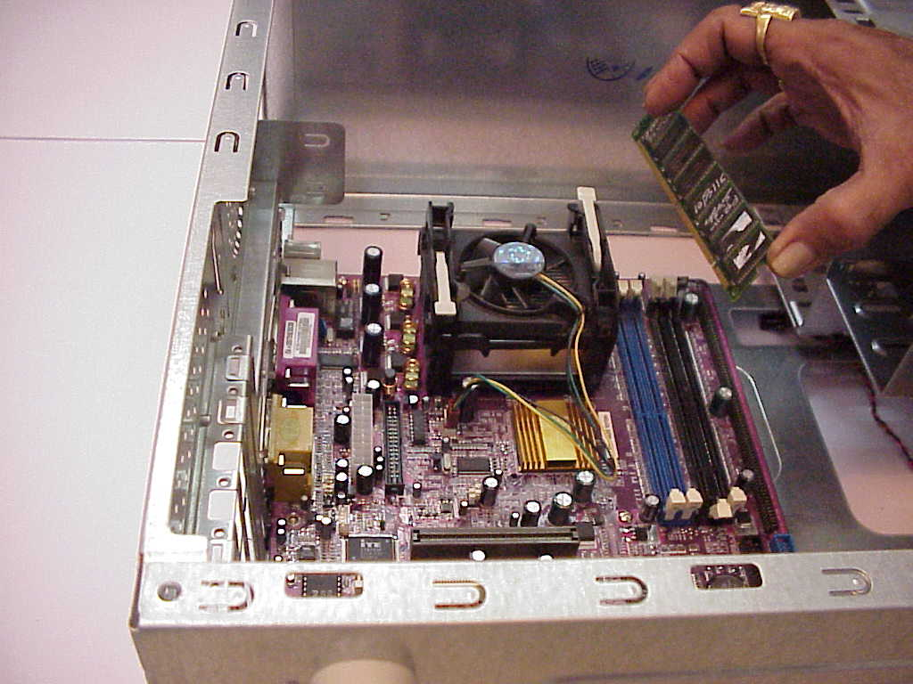

- Step3: CMOS Battery installation (configure, Clock speed, Jumper and multiplier Jumper)
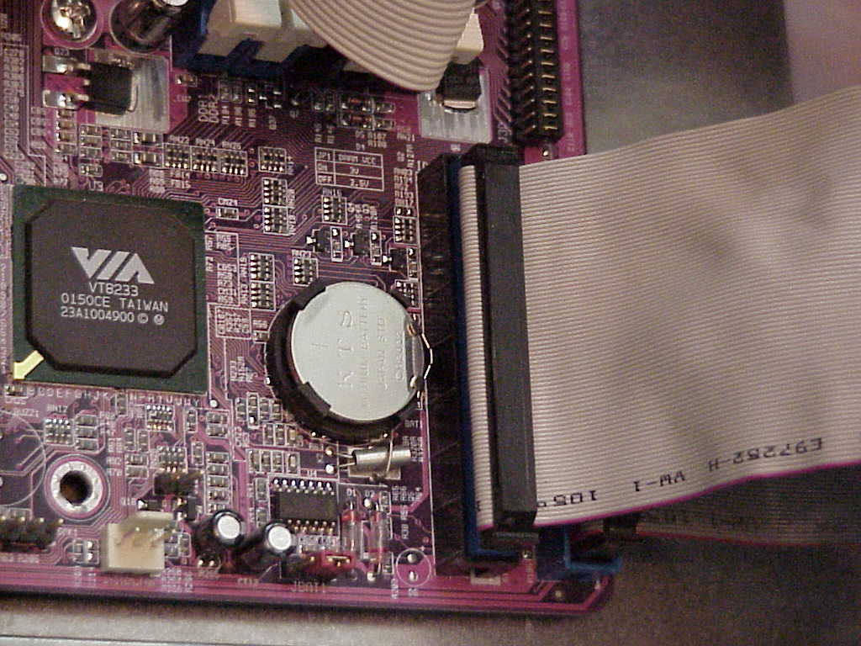

- Step4: Install motherboard is case. Install wires for front panel and mother power connectors.

- Take antistatic precautions property mount motherboard and screws it with screws gently, properly aligns expansion slots and ensure ports. Proper accessibility at the back.
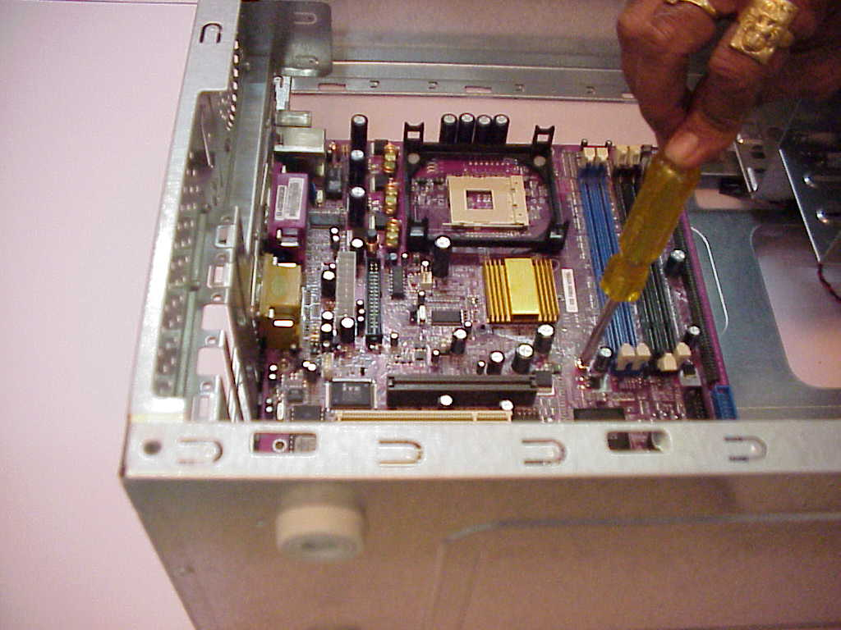

- Step5: Case wiring (front panel ports) connect various wires like those power led, Keys which restart switch, HDD led, Turbo switch and etc. to corresponding motherboard positions.

- Step6: Install the power supply (install SMPS)

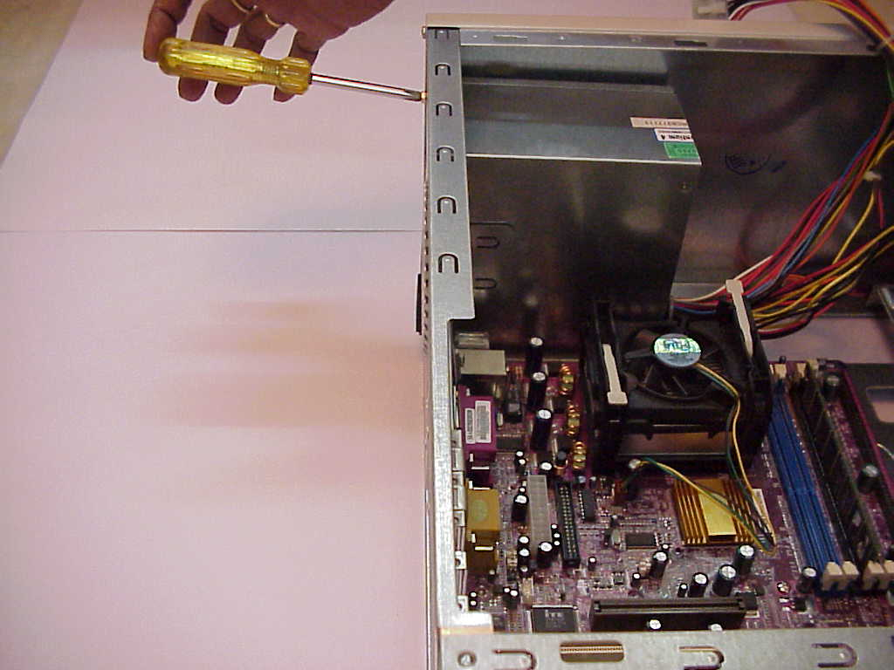

- Step7: Hard disk drive system installation. As Motherboard already provides a aide HDD controller, simply connect hard disk drive to this controller, and enable controller. Take HDD cable of 40 Pins and attach correct and to the 40 pin HDD header on the Motherboard
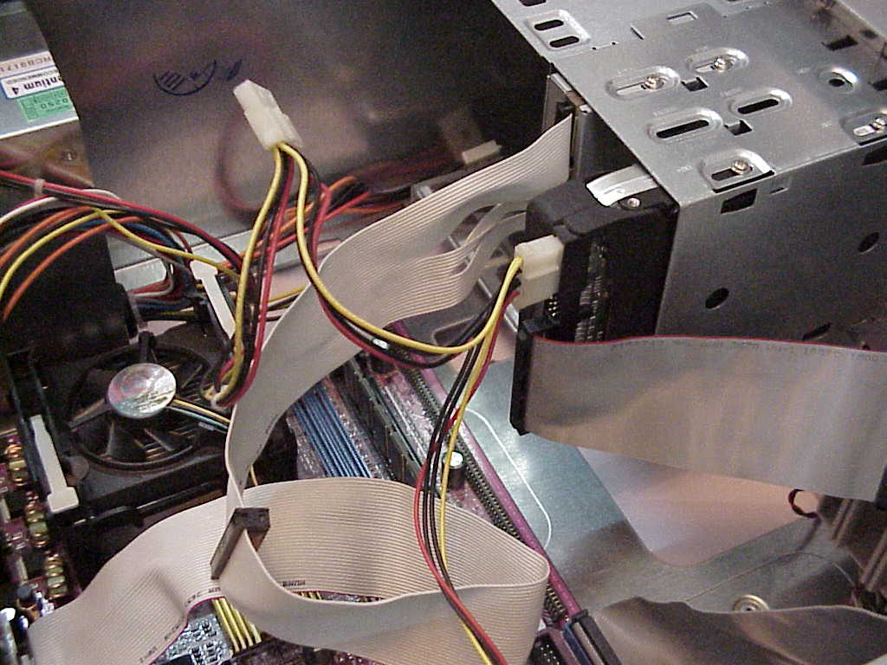

- Step8: CD-ROM Drive:
- Installing on IDE (Integrated Development Environments) secondary channel of the controller. Explain connections pin alignments, master slave combination.
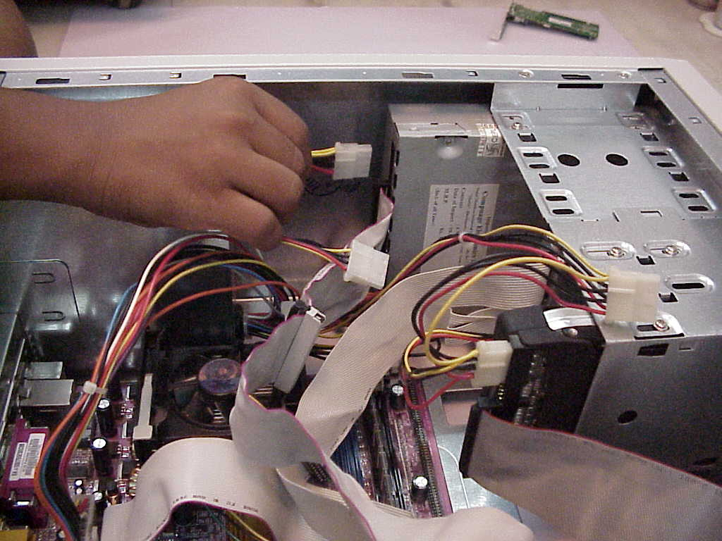

- Step9:Floppy drive installation
- If controller already is motherboard, don’t install a new controller, simply connect the floppy drive cable to an attach the controller. End to the 34 pin floppy drive disk (FDD) Header on the motherboard (take care of pins Alignments)
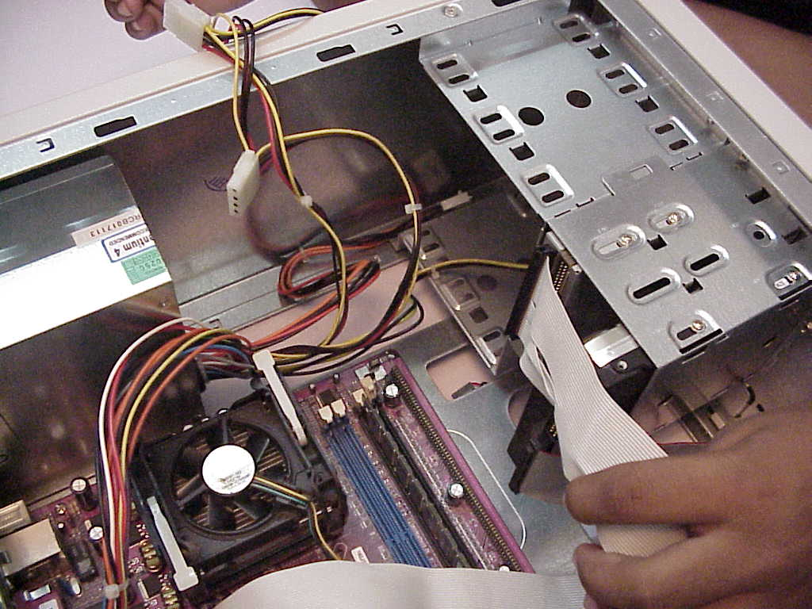

- Step10:Sound board Installation:
- Installing an audio card, which use different interrupts .IVO address and one DMA channel(Direct memory access). Beware of hard complies plug and plug type to do automatically other jumper settings like MIDI and game board setting.

- Step11:System precaution:
- Before closing things up, check whether all Hardware is physically, properly installed and connected before installing on hard disk, check the following.
- Securing of motherboard , expansion boards and etc., no louse screws.
- Check proper seating of expansion cards no interference with CPU RAM Chips.
- Routing properly , Ribbon cables etc.. always from heat of supply , Fans, Video ports.

- Step12: Back up the CMOS
- If motherboard has a video port already attached. Connect monitor to this port , enable video controllers, loading monitor drivers, choosing resolution.

- Step13:Keyboard Installation
- Attach the keyboard cable to the corresponding port in the case. This port would be connected to motherboard.

- Step14:Install the Mouse
- If there is a serial port to connect attach cable to proper connectors.
- Explain difference with PS/2 mouse and adaptor
- Explain bus mouse and how it is configured in open ISA slot.

- Step15:Burn in Test
Check component Failures by keeping devices and PC powered on long periods after it is completely and successfully assembled.

- Step16:Step Button Up
- When all hardware components installed and connected, PC Powered on and everything working properly than close the outer casing and bolt it

